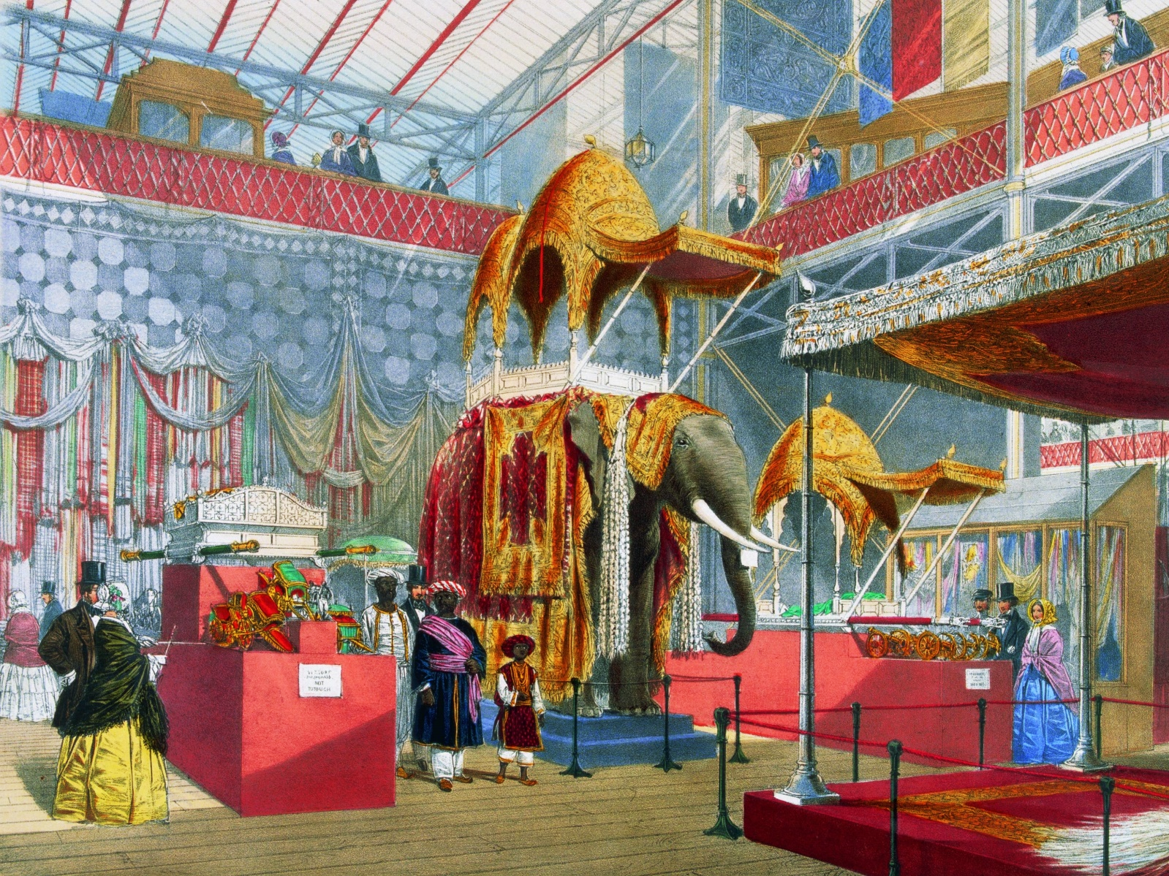
Empire and ‘the Other’
Impact and Legacy
The Centre for Imperial and Postcolonial Studies Postgraduate Conference

Wednesday 19th July 2017

“The power to define the other seals one's definition of oneself” – James Baldwin
Conceptions of ‘the other’, or more specifically ‘fear of the other’, have become an increasingly visible factor in the global, national and local climate; effecting the direction of national and international policy, the outcome of elections and referendums, and individual interactions within communities. However, in the academic context, scholars are increasingly at ease with complexity, chiefly through considerations of, and focus upon, transnationalism, hybridity, and diversity. Can investigating imperial othering, in light of a contemporary resurgence of the issue of ‘otherness’, still yield fresh analytical insights? Does the imperial and post-colonial context of ‘othering’ illuminate our understanding of the present day?
To help address these issues, the Centre for Imperial and Postcolonial Studies aims to bring together postgraduate and early career researchers from a variety of perspectives and disciplines to present original research papers on the theme of the impact and legacy of ‘the other’ within the field of imperial and postcolonial study. The conference aims to address such questions as: How does engaging with the concept of ‘the other’ inform and advance our understanding of imperial and postcolonial experience? How do characterisations of ‘the other’ effect empires and the postcolonial landscape? Is ‘othering’ a fundamental aspect of empire, and does this notion extend into the postcolonial world? What contradictions emerge between the idea of ‘the other’ and experience of ‘the other’? Have the means of ‘othering’ changed over time? How far has the legacy of imperial othering helped shape the modern world?
Potential paper themes within the scope of imperial and postcolonial studies might include but are not limited to:
- Constructing, Protecting and Exporting Identities
- Contact, Conflict and Engagement
- Immigration, Emigration and Diasporas
- Representation and Misrepresentation
- Communalism, Nationalism and Internationalism
- Intellectual, Ideological, Political and Religious Discourse
- Authenticity
- Memory and Nostalgia
Please submit abstracts of no more than 300 words for a 15-20 minute paper by Friday 26th May to: jajh1g09@soton.ac.uk.
Abstracts should be formatted in a Word file, saved with your full name, discipline, institutional affiliation and paper title, and attached to the email. Abstracts will be reviewed and confirmed by Friday 9th June.
There is a very modest fund available to help with the cost of travel for some speakers. Please state in your email whether you wish to be considered for this fund, along with an estimation of transport costs.
If you simply wish to attend please register your interest to the above email address.

